Installation of Ubuntu on Windows using WSL: https://www.youtube.com/watch?v=wjbbl0TTMeo
Installation of Ubuntu on Virtual Box.
You can refer to this video: https://www.youtube.com/watch?v=DhVjgI57Ino
Step 1. Installation of Virtual Box
- Go to https://www.virtualbox.org/wiki/Downloads
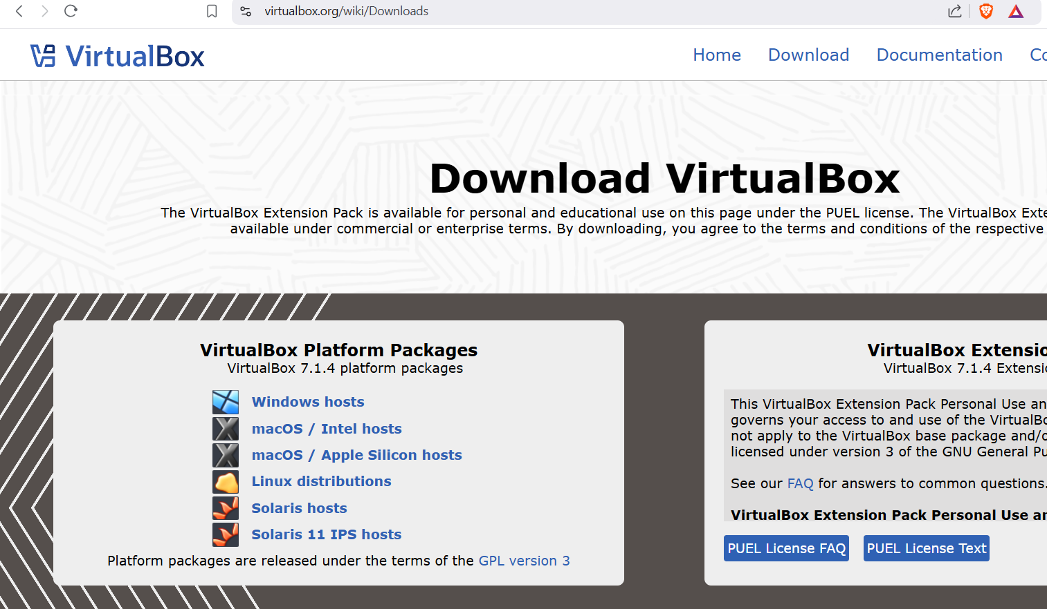
- Download the virtual box as per your OS. (i.e. Windows/macOS) and install Virtual Box.
I am using virtual box Version 7.0.10. Which can be downloaded from:
https://www.virtualbox.org/wiki/Download_Old_Builds_7_0

Note:
For missing dependencies python core/win32api refer the following link.
https://www.sysnettechsolutions.com/en/fix-python-win32api-virtualbox/

Step.2: Download Ubuntu .iso file. (https://old-releases.ubuntu.com/releases/) I am using Ubuntu 20.04 Focal Fossa
Step.3: Create a New Virtual Machine in Virtual Box.
- Open VirtualBox and click on the "New" button to create a new virtual machine.

- In the "Name and Operating System" window, enter a name for your virtual machine (e.g., "Ubuntu 24.04 LTS"). Ensure the "Type" is set to "Linux" and the "Version" is set to "Ubuntu (64-bit)".
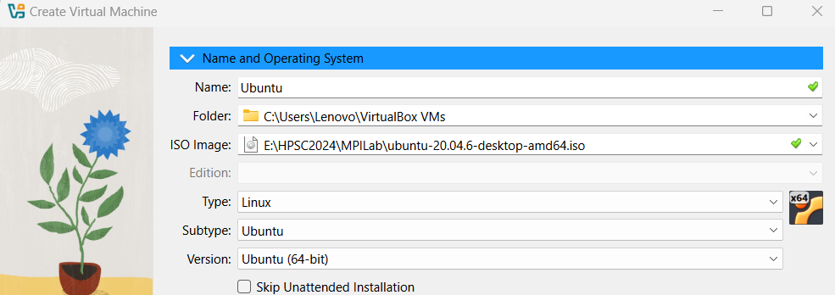
- Click "Next" to proceed./Go to Hardware section.

Step 4: Allocate Memory (RAM)
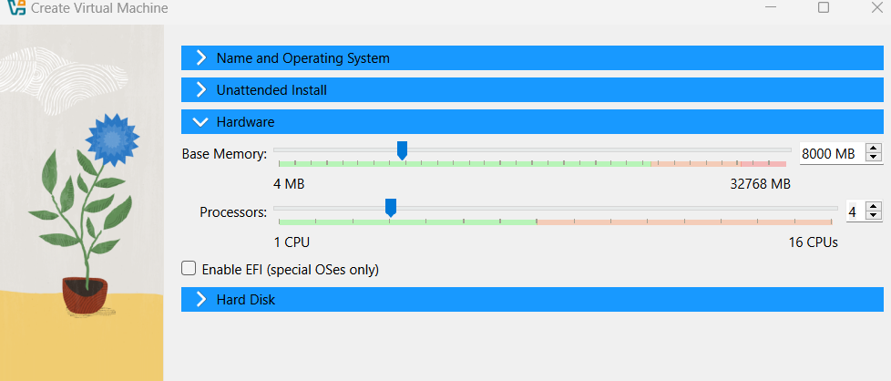
- In the "Memory Size" window, allocate the amount of RAM for your virtual machine. A minimum of 2048 MB (2 GB) is recommended, but you can allocate more if your system allows.
- Allocate Processors depending on the availability of CPU cores in your system.
3. Click "Next" to continue/Go to Hard Disk section.
Step 5: Create a Virtual Hard Disk
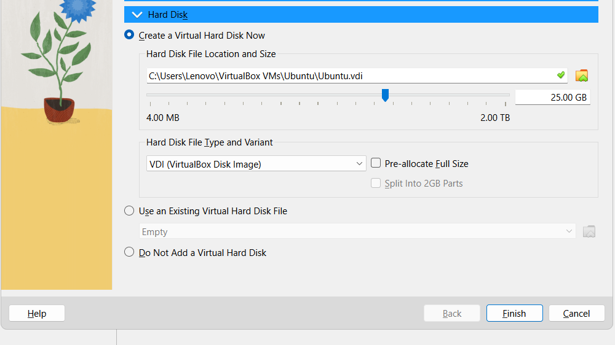
1. Select "Create a virtual hard disk now" and click "Create".
2. In the "Hard Disk File Type" window, choose "VDI (VirtualBox Disk Image)" and click "Next".
3. For "Storage on Physical Hard Disk", choose either "Dynamically allocated" or "Fixed size" based on your preference. "Dynamically allocated" is more flexible./Do not tick on Pre-allocate Full Size.
4. Click "Next" to proceed.
Step 6: Specify the Size of the Virtual Hard Disk
1. Set the size of the virtual hard disk. A minimum of 25 GB is recommended for Ubuntu.
2. Click "Create" to finish setting up the virtual hard disk.
Step 7: Configure the Virtual Machine Settings
1. Select your newly created virtual machine in the VirtualBox Manager and click on "Settings".
2. Go to the "System" tab and ensure that "Enable EFI" is unchecked (unless needed for specific purposes).
3. Go to the "Storage" tab, click on the empty optical drive under "Controller: IDE", then click on the disk icon and choose "Choose a disk file".
4. Locate and select the Ubuntu 24.04 LTS ISO file you downloaded earlier.
5. Click "OK" to save the settings.
Step 8: Start the Virtual Machine
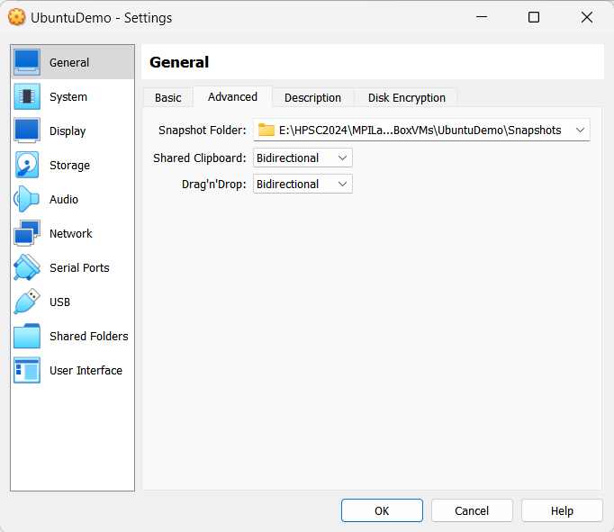
Before starting Ubuntu installation,
1. With your virtual machine selected, click on the "Start" button.
2. The virtual machine will boot from the Ubuntu ISO file. Follow the on-screen instructions to install Ubuntu.
Step 9: Install Ubuntu 24.04 LTS
1. Select "Install Ubuntu" from the options.
2. Choose your language and keyboard layout.
3. Follow the prompts to set up your installation preferences, including updates and third-party software.
4. Select "Erase disk and install Ubuntu" (this will only affect the virtual hard disk).
5. Follow the remaining prompts to create your user account and complete the installation.
Step 10: Finalize Installation and Reboot
1. Once the installation is complete, restart the virtual machine when prompted.
2. Remove the installation media by going to "Devices" - "Optical Drives" - "Remove disk from virtual drive" in the VirtualBox menu.
3. Press "Enter" to reboot your virtual machine.

Installing MPI
- Open terminal and enter
sudo apt install mpich

Note:
For missing dependencies python core/win32api refer the following link.
https://www.sysnettechsolutions.com/en/fix-python-win32api-virtualbox/

